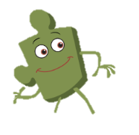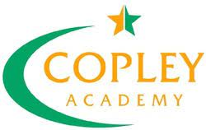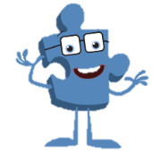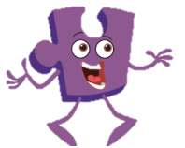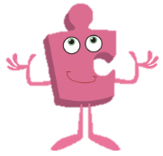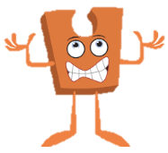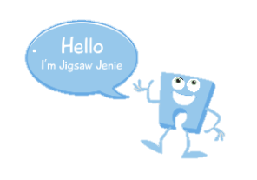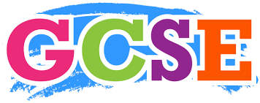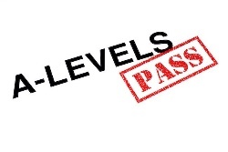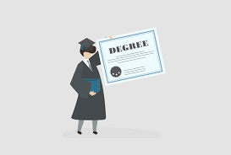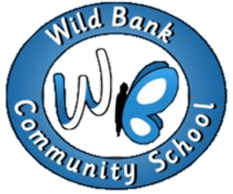

Self-Image & Body Image

Puberty for girls & Boys

Conception

Recognsing Me

Safety with Online Communities

Online Gaming

My Relationship

Smoking & Alcohol

Emergency Aid

Body

My Relation with Food.

When I grow up- Lifestyle

Investigate Jobs & Careers

My Dream Jobs

Different Cultures

Racism

Rumors & Name Calling

Types of Bullying

My Year Ahead

Being a Citizen of my Country

Rights, Responsibilities, Democracy

Judging by appearance

Understanding Influences

Understanding Bullying

Becoming a class team.

Being a school citizen

Rights, Responsibilities, Democracy

Jealousy

Love & Lost

Memories

Getting on & Falling out

Unique me

Having a baby

Girls and puberty

Looking Ahead

Groups Dynamics

Smoking

Alcohol

Healthy Friendships

Hopes & Dreams

Broken Dreams

Overcoming Disappointment

Create New Dreams

Families & Friendship

Keeping myself safe online

Being a Global Citizen

Being Fit & Healthy

What do I know about drugs?

Being safe & Unsafe

Family Conflicts

Witness & Feelings

Words that harm

Dreams & Ambitions

New Challenges

Overcoming Challenges

How babies grow?

Outside Body changes

Inside body changes

Nightmare school Vs Dream school

Rewards & Consequences

Learning in charter

Goals to success

My learning strengths

Group Challenges

Families

Keeping Safe- Avoiding Physical contact

Friends & Conflict

Secrets

Life Cycles in Nature

Growing from young to old

The Changing me

Being Healthy

Being Relaxed

Medicine Safety

Healthy Eating

Boys & Girls

Why does bullying?

Standing up for myself.

Gender Diversity

Hopes & Fears

Rewards & Consequences

Rights & Responsibilities

Life Cycles

Changing Me

My Changing Body

Girls & Boys Body

Family & Friends

Greetings

People who help us

Steps to Goals

Achieving together

Overcoming Obstacles

Same as and differences

What is Bullying

Making new friends

Special & Safe

My Class

Rewards feeling proud

Rights & Responsibilities

Healthy Choices

Clean & Healthy

Medicine Safety

Road Safety

Respecting my body

Growing Up

Celebration

Aspiration & Goal

How to achieve our goals and emotions that go with this.

My Family and Me

Friendship

Falling out- Part 2

School community

Our Body

Food Glorious difference food

Keeping Clean

Safe adults

Respect for similarity and difference. Anti-bullying and being unique

Helping others to feel welcome

Being at school

Gentle Hands

Rights & Responsibilities

Aspiration & Goal

How to achieve our goals and emotions that go with this.

Being and keeping safe &

healthy

My Body

Growing up

Fun & Fears

My Family and Me

Friendship

Falling out

I am special

Families

Making friends

Sharing our feelings

Being at Nursery

Gentle Hands

Rights & Responsibilities

Year 2

Year 3/4

Year 6

Year 4/5

Year 1

Reception

Nursery

PSHE Curriculum Map